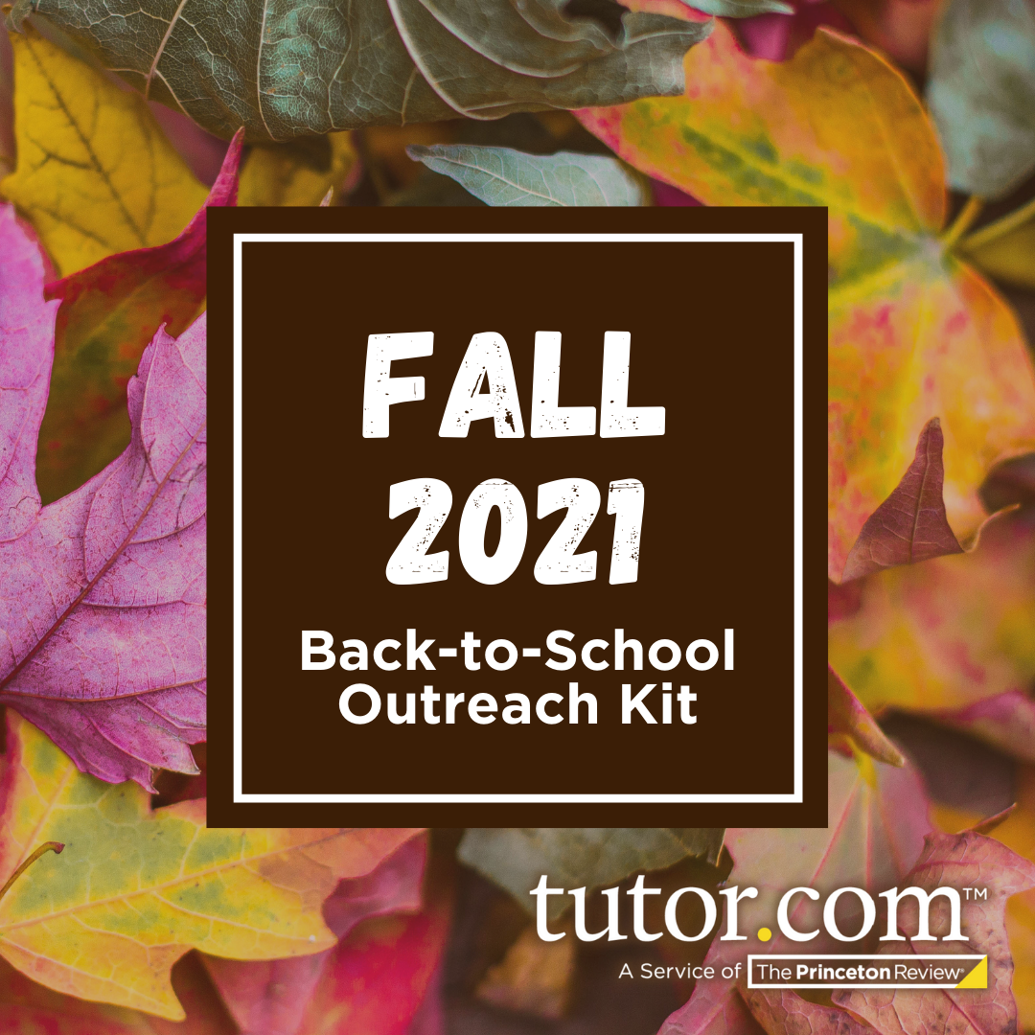
for Library Partners
You can use the messaging below in patron emails, social media posts, or on your library website! These templates are customizable to fit your timeline and messaging needs. (Just fill in your library’s name and access instructions where indicated.)
Timeline | Messaging | Optional Graphic (preview)
Late Aug/  Early Sep | Kick Off the School Year Right (K-8 learners)  Did You Know? [Library Name] partners with Tutor.com to provide learners of all ages with free online tutoring throughout the year!  To get 1-to-1 help in any of 100+ subject areas, simply connect with friendly expert tutor online and on demand.  To get started, go to [insert your Tutor.com program access instructions here].  Start the Semester Strong (High school & college students)  Did You Know? [Library Name] partners with Tutor.com to provide students with free online tutoring and test prep resources to help you throughout the year!  Connect with an expert subject tutor to get the specialized help you need. To get started, go to [insert your Tutor.com program access instructions here].
Late Aug/  Early Sep | Free Job Search Help (Jobseekers)  Did You Know? [Library Name]’s Tutor.com program provides free career resources to all patrons. Get the guidance you need to land a job—including resume review, interview prep, and help with online job applications!  To get started, go to [insert your Tutor.com program access instructions here].  TIP: Check out Tutor.com’s Professional Job Search Webinar Series on YouTube for tools and tips to help you succeed in the job market.
Mid-Sep | SAT®/ACT® Essentials: Prep to Earn Your Target Score  Need to prep for the SAT® or ACT®? We can help! Log in to Tutor.com to access practice problems, drills, and video lessons from The Princeton Review®! [Insert access instructions here.]
Mid-Sep | Stay On Track with AP® Subject Tutoring  Looking for help in your toughest classes? [Library Name]’s Tutor.com program provides FREE expert tutoring in many AP subject areas—so you can review concepts and be prepared come exam day.  To get started, [insert your Tutor.com program access instructions here].
Late Sep | Need Help with Math? (High school, college, and adult learners)  Tutor.com can help—and it’s free through [Library Name]! Get online, on-demand tutoring in math, from Algebra to Geometry, Calculus, and more. [Insert your Tutor.com program access instructions here].  Need Homework Help? (K–8 learners)  With your library card, you can get help online and on demand from a friendly tutor! [Library Name] offers free tutoring through Tutor.com in a number of subjects and at any grade level. To get started, [insert access instructions and hours of availability here].
Early Oct | Midterm Madness?  Don’t panic! Connect with an expert online tutor FREE to help you prepare for your exams.  [Library Name] offers free on-demand tutoring through Tutor.com. All it takes is a few clicks: [Insert your Tutor.com program access instructions here].
Mid-Oct | Don’t Fall Behind  Worried about falling behind this fall? Connect with an encouraging online tutor today to get the subject help you need—FREE through [Library Name]’s Tutor.com program.  Get started at: [Insert your Tutor.com program access instructions here].  (TIP: Check out new Study Skills topic areas to get expert advice on time management, getting organized, and more!)
Late Oct | Don’t Let Schoolwork Haunt You!  Are homework due dates, quizzes, and test days creeping around every corner? Work online with a friendly, knowledgeable tutor to complete assignments and prep for upcoming tests—FREE through [Library Name]’s Tutor.com program.  [Insert your Tutor.com program access instructions here.]
Early Nov | Writing Help  Get help from an expert writing tutor at NO COST through [Library Name]’s Tutor.com program! You can connect with a live tutor for brainstorming and organizing, or upload a draft and receive expert feedback via the drop-off writing review feature.  [Insert your Tutor.com program access instructions here.]  TIP: Be sure to check out Tutor.com’s Writing Service Guide to learn how to get the most out of this free service!

Mid-Nov | Stay Strong, Not Stressed (K–8 students)  Is your child stressed at school? Are you stressed, too? [Library Name]’s Tutor.com program can help!  Encouraging, knowledgeable online tutors are available at NO COST to help you and your child work through the toughest subjects. Learners can connect to get Study Skills coaching, and you can find Parent Coaching for Student Success subjects—all geared torward helping students achieve their goals.  To get started, [insert your Tutor.com program access instructions here].  Feeling Stressed? (High school, college & adult learners)  Looking to relieve stress, get better organized, and gain the skills you needs to succeed? Watch Tutor.com’s Student Success YouTube series to help guide you through the rest of the semester.  Tutor.com YouTube Playlist: https://youtube.com/playlist?list=PLsfPyukV1bQ3qosAjSgAYxuH3eGw1FnL3  Remember to take advantage of free online tutoring and test prep through [Library Name]’s Tutor.com program! You’ll even find 1-to-1 study skills coaching and parent coaching subjects to help learners stay on track and achieve their goals.  [Insert your Tutor.com program access instructions here.]
Late Nov– Early Dec | Knock Your Finals Out of the Park  Prep for your exams ahead of time by working with a friendly and knowledgeable online tutor—free through [Library Name].  [Insert your Tutor.com program access instructions here.]

Download hi-res versions of all of the graphics in this calendar in a convenient ZIP format:
Tutor.com for Libraries: Fall 2021 Outreach Kit

SAT® is a trademark registered by the College Board, which is not affiliated with, and does not endorse, this product. All tests are registered trademarks of their respective owners. None of the trademark holders is affiliated with The Princeton Review or this product. The Princeton Review is not affiliated with Princeton University.

